**Lesson 3 APP18**

**Empty an S3 Bucket**

**Selecting the S3 bucket you want to empty**

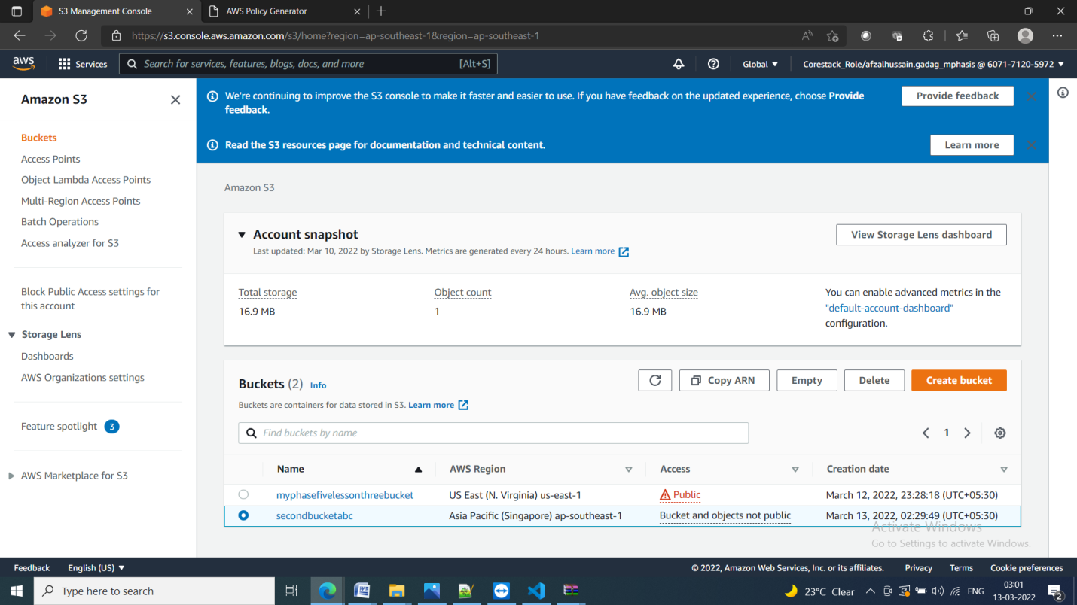

**Emptying the bucket**

* Verify the content present in the bucket

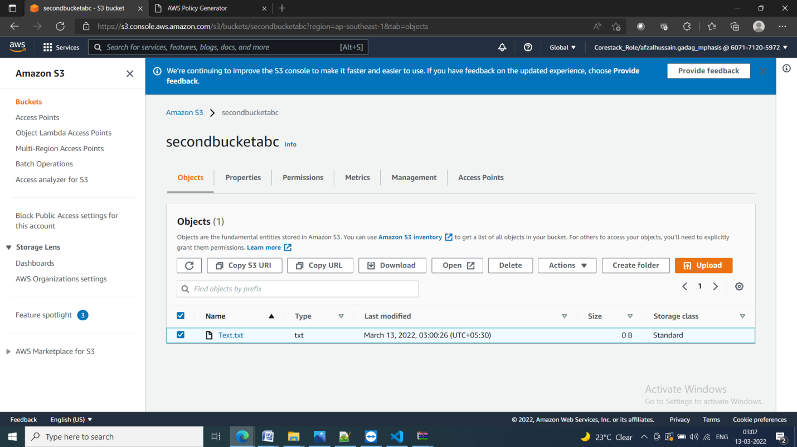

* Empty the bucket

